**Robo Phantoms**

**#23954**

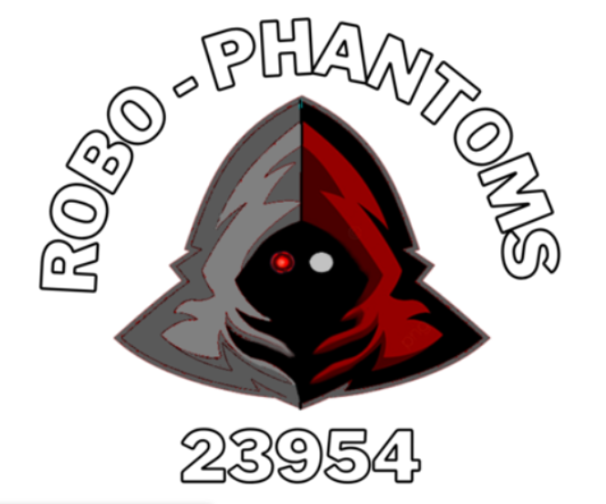

**Website:** <https://sites.google.com/view/robophantoms?usp=sharing>

**YouTube**: <https://www.youtube.com/@user-jq7jn5wu3b>

**Instagram**: @robophantoms23954

**GitHub**: <https://github.com/srinathmadasu76/FTC_2023/tree/main/Code>

**Team**

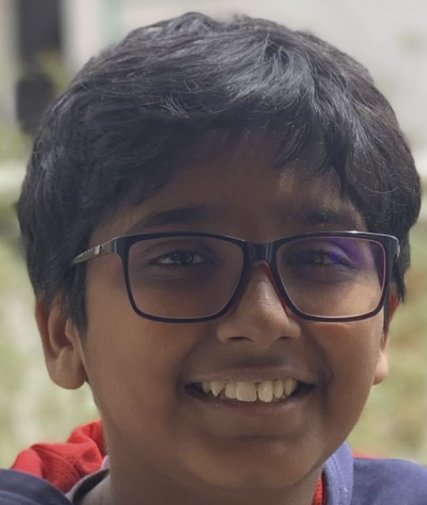 

Dhruv Shah - Driver 1/CAD Designer Coach: Srinath Madasu

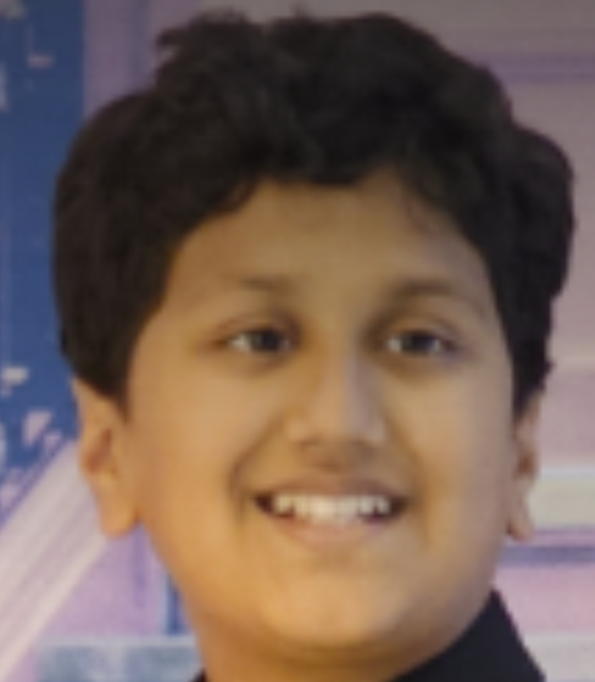 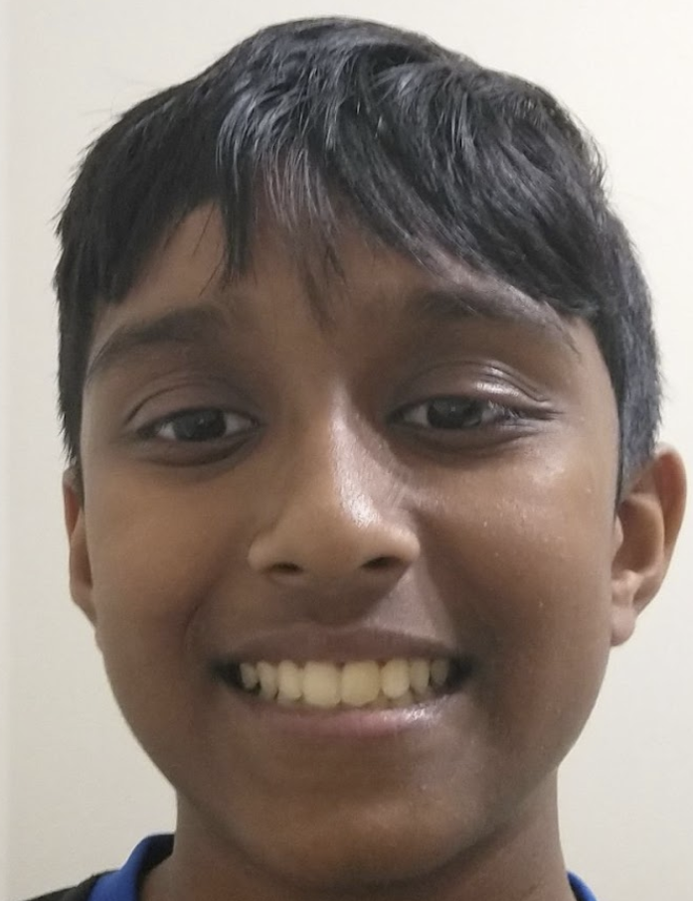

Harsh Desai - Maintenance Kavin Sankaran – Head Programmer

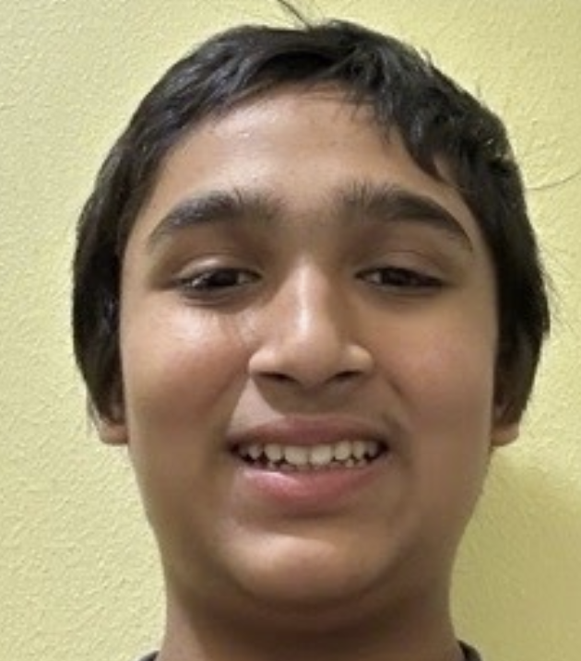 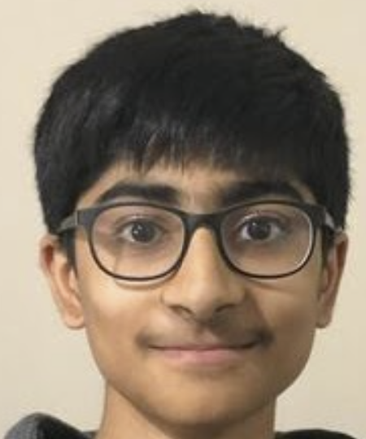

Srilakshminath Madasu - Driver 2/Builder Kayan Patel - Assistant Programmer

Table of Contents

1. **Team Mission Statement 2**
2. **Game Analysis and Strategy 2**
3. **Research and Information Documentation 3**
4. **Brainstorming and Concept Development 5**
5. **Comparative Analysis of Concepts 6**
6. **Design and Development 6**
7. **Analysis and Selecting the Preferred Design 7**
8. **Detailed Design 7**
9. **Materials and Components 7**
10. **Project Implementation 9**
11. **Results and Data 10**
12. **Lessons Learned 10**
13. **Sustainability 12**
14. **Mentorship and Knowledge Acquisition Strategies 13**
15. **Future Work for the Project 13**
16. **Team Plan 13**
17. **References 14**

**Appendix 15**

1. **Team Mission Statement**

We are a rookie FTC team all in our first year. Our team includes 5 hardworking kids and 1 strong coach. We want to spread awareness for the FIRST organization to inspire other people our age and younger to get involved in the robotics and technology field at an early age. We were very excited when we got the opportunity to participate in FTC and want other people to also have the same experience and have fun while learning about robotics. We do this by conducting fundraisers and always telling our friends about FIRST. We are very dedicated and meet every week to work on our robot and do the best work we can to conduct “Gracious Professionalism”.

1. **Game Analysis**

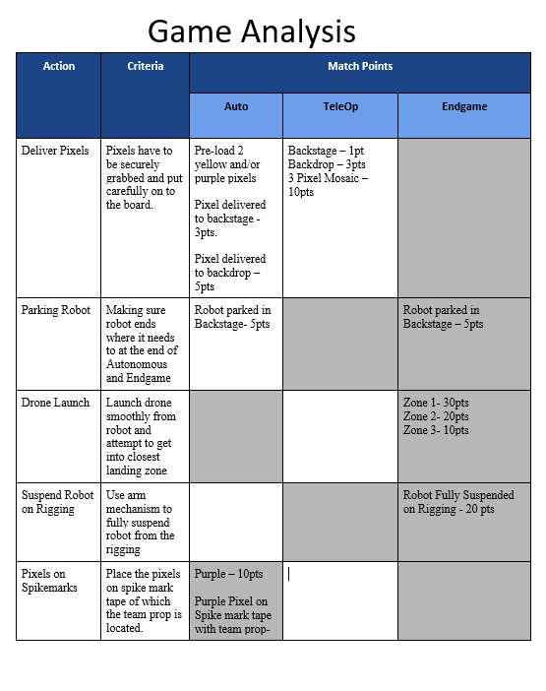

1. **Research**

**DRIVETRAINS**

|  |  |
| --- | --- |
| **Omni Wheels** | * Omni wheels have rubber rollers around the circumference of the wheel. This allows the wheel to roll perpendicular to the direction the wheel is driven. |
| **Mecanum Wheels** | * Each side requires one left wheel and one right wheel to operate. When set up correctly, this allows **omni-directional movement** (movement in all directions). |
| **Traction Wheel** | * Traction wheels are designed for **maximum grip.** * These are the regular forward and backward wheels. |

Intake/Outtake

|  |  |
| --- | --- |
| **Horizontal Intake** | The Horizontal Intake works by rotating on a horizontal  plane. This type of intake is best used for smaller game items. |
| **Vertical Intake** | The Vertical Intake works by using wheels or other  components to intake the object. |
| **Compliant Wheels** | Compliant wheels are pieces of wheel shaped rubber, usually  used for the Intake mechanism of a robot. |
| **Rubber Band Intakes** | Rubber Intakes are made by 2 wheels on either side and  rubber bands stretched in between them. This creates a sort of roller that can  intake balls. |
| **Surgical Tubing Intake** | Surgical Tubing Intakes can be spring loaded into the robot.  Mostly used when the robot needed to transport smaller objects to a higher or  elevated surface. |

Transfers

|  |  |
| --- | --- |
| **Flip up transfer** | The robot has a collector that intake the game element while the collector “Flips up” to transfer into a second mechanism” |
| **Direct transfer** | The robot intakes and transfers into a bucket for scoring |
| **Conveyor transfer** | Multiple items can be transferred, items can be continuously transferred |

Arms

|  |  |
| --- | --- |
| **Single arms** | Very easy to build , useful in low load applications |
| **Multi axis arms** | Can get in arm in multiple different angles |

1. **Brainstorming and Concept Development**

As we first started our competition, we had to figure out what type of equipment we could use like a claw, hook, bucket, etc. There were millions of options we could choose from, but there was only one that would work best for us. As we started designing, we looked at Tinker CAD and Fusion 360 to start making a build idea for any action we were planning to do in the game and which one would make the most effective output when putting the pixels on the backboard. We started to group the ideas, like taking the pixels from the human player, the stack or just push the pixels in. All of these groups were really good, but we needed to figure out which one was the best. So, we went to Fusion 360 to make a prototype and go on a simulator FTCSIM to see if it worked on the FTCSIM. From all of this brainstorming, we needed to figure out which one was the most consistent of them al. After all of this, we also did research on different types of wheels that we could use, like omni-directional wheels or mechanical wheels.

Truss

H

$∝$

Robot

D

The initial guess for the drone flight angle was determined by using geometric concepts as shown above. The drone flight angle (α) is

$$\tan\left(∝\right)=\frac{Truss Height (H)}{Distance from Truss (D)}$$

The drone flight angle was later tuned based on the experiments due to air resistance and the friction in the release components.

The robot was designed to maintain a low center of gravity (CG) to reduce drift and imbalance. Also, lower CG helped to lift the robot easily. All the components in the robot were designed to fit within the robot specifications and efficiently perform the mechanisms. The initial guess for the robot travel time to the target was based on simple distance speed relationship as shown below:

$Robot Travel time= \frac{Distance}{Speed}$

The initial travel time was later tuned to account for mat friction, unevenness in the mat and robot drift.

The hanging of the robot was made possible through calculations based on weight of the robot, motor rpm and gear ratio.

$$Gear Ratio=\frac{Rotation Per Minute}{Robot Weight}$$

1. **Comparative Analysis of Concepts**

At the start of our season, we had different choices for intake such as rack and pinion, linear slides, a claw or a bucket, etc. We had to carefully think since each mechanism had its own advantages and disadvantages, like rack and pinion which did not have a long reach at the same time, the linear slides also did similar functionality with an inefficient time but were working as well. Also, with the claw, it was very inconsistent but worked but then the bucket was very consistent and worked at a quick and fast rate.

1. **Design and Development**
2. ***Conceptual design***

At the start of the season, we went through several ideas to get to this final version. All of our designs start off on paper then move to cad to get the precise parts. A couple of early designs were a couple versions of a claw and later went to active intake. All of the designs were chosen strictly based on numbers as we believe that the numbers are ground truth. Some of the CAD design was done on Onshape. We used it for the six boxes the drone, battery holder, uptake device, and our 2 team props. Our robot design was innovative and unique in designing the box for intake and dropping the pixels.

***b.*** ***Prototyping and Testing***

One of the first ideas that struck us was a single claw mounted on an arm. We initially drew out then CAD it and bought the parts necessary to build it. This idea was crucial for us to do as it let us know the flaw with the claw which was how precise we needed to be. Through the testing of this we came to our next design. It was an active intake with a grabber on a rack and pinion. After we went to this design, we realized a couple of things. Since the pixels were on the ground, they could likely get caught on something and we could lose them. The next one we went to was an intake into a single pixel box. This was a really well proven design used till lm1 but later changed to a two-pixel box which was found to be very effective.

***c.*** ***Modifications and Iterations***

Through the designs we have been heavily iterating. We have about eight iterations of our two-pixel box to make it as effective as possible. We have also modified our drone launcher and hang. We started out with just a rubber band to shoot the drone but soon realized that the power was not enough , so we finally ended up going to a slider to ensure there is equal and large amount of force on the drone. Secondly, our hang has gone through lots of iterations too we started out with a tape measure and realized that it got to wobbly at the top and so we switched to arm with magnets to ensure the hook stays on and then use a winch to pull.

7**.** **Analysis and Selecting the Preferred Design**

|  |  |  |
| --- | --- | --- |
| Name | Time to pick up (from hp) | Pixels scored (Backdrop) 2:00 min |
| Basic claw | 12 sec | 2 |
| Rack p claw | 8 sec | 3 |
| Single box | 4 sec | 7 |
| Double box | 2 sec | 9 |
| Final - | Double box | Chosen - most efficiency |

**8.** **Detailed Design**

For the design of the dual box, we CAD it out. We made the box a little bigger than two pixels to allow for error. For the arm we used a motor and powered it through bevel gears to prevent excessive stress placed on the motor. We also used an extension powered by a linkage to allow us to reach higher. Through the addition of weight to the arm we faced a big issue . In our PIDF loops we had to run a heavy amount of current. Due to this high amount, we faced issues with the hub restarting. To counteract this, we counter sprung the arm to make the arm like dead weight. To calculate the amount of tension needed we used a simple formula . We used Hooke’s law f=-kx to calculate the spring tension.

[**https://cad.onshape.com/documents/e2df1e251848d1c9a12e87cf/w/957c88f8fff3655d6907fbc8/e/9925aafd3e291e6bcf4b717c?renderMode=0&uiState=65a55210d282054fd4bbc8f0**](https://cad.onshape.com/documents/e2df1e251848d1c9a12e87cf/w/957c88f8fff3655d6907fbc8/e/9925aafd3e291e6bcf4b717c?renderMode=0&uiState=65a55210d282054fd4bbc8f0)

**9.** **Materials and Components**

For the materials we used a standard aluminum channel and aluminum extension seated on bearing guides . We used two servos on the arm . One for extension and another one for the wrist . For the extension we used a gobilda torque servo and a speed servo for the bucket . The bucket was made from (Polylactide) PLA and used a high infill to keep it strong . Below figure shows all the different components of the robot:

* Arm
* Drone Launcher
* Hanging Assembly
* Dual Box

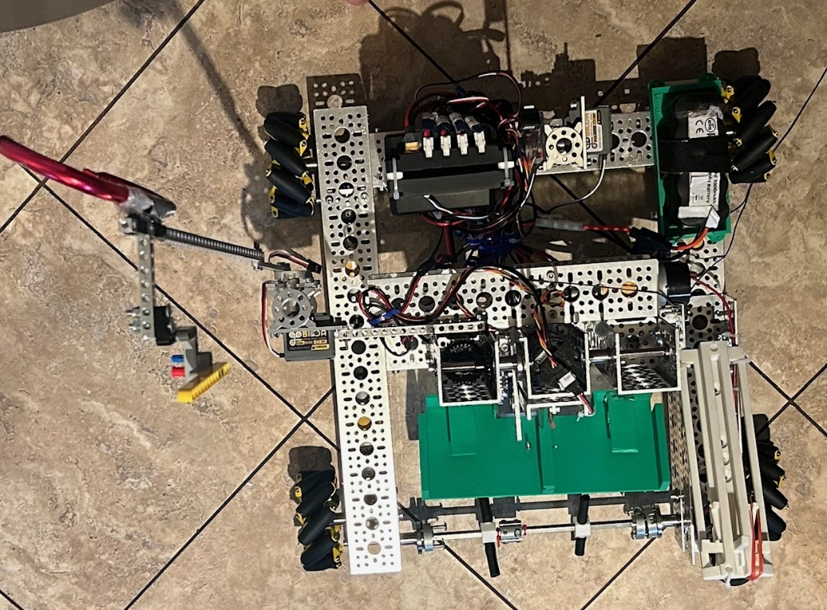

Arm

Hanging Assembly

Drone Launcher

Outtake – Dual Box

Intake – Surgical Tubing

**10.**      **Project Implementation**

For the drivetrain, we used mecanum wheels to allow for strafing. Our intake uses surgical tubing in which we used 3D printed carriers to hold them in place. Our outtake is a bucket that goes down to drop the pixel. We used the REV Control Hub. As for software, we used Android studio (Java) to code all the autonomous and driver-controlled actions. We used to GitHub to share the code within the team and the location of code is at: <https://github.com/srinathmadasu76/FTC_2023/tree/main/Code>. Our autonomous codes detect where our team prop is using a distance sensor. and place a pixel on the tape it is on. This works about 60% of the time. Then it goes to the backdrop and places the pixel on it.

**11.**      **Results and Data**

Our original autonomous program worked 80% of the time, because in the rear autonomous, the wheels would strafe and would not park. Our current autonomous works 20% of the time. It would rarely drop the pixel on the spike marker tape and put the pixel on the backdrop. During the drive control period, we were able to get 6 pixels on the backdrop during a 2-and-a-half-minute period. Our drone was one of our most consistent parts of our robot. It worked 100% of the time, getting 10 – 20 points every time. Our hanging worked 20% of the time and was not very reliable to the point that parking would get more points. We have the following innovative features in the robot:

|  |  |
| --- | --- |
| **Mechanism** | **Innovative Idea** |
| Outtake | Two boxes for picking 2 pixels |
| Hanging | Winch |
| Auton pixel dropping | Mechanical trigger |
| Auton Team Prop Detection | Innovative idea using Touch Sensor |

**12.**      **Lessons Learned**

**Object Detection and Autonomous Improvements**

The distance sensor also is not reliable enough so we will use a touch sensor. The distance sensor would not detect the team prop entirely and detect something else farther away. We were going to use a webcam to detect the team prop. We would do it by checking which spike marker tape had the most color saturation and proceeding the autonomous code from there. To detect the team prop, we used 2 distance sensors, but we found out that they interfered with each other. They would detect both spike marker tapes and would confuse the robot. We then changed to 1 distance sensor. For future autonomous actions, we will want to take from the pixel stacks. This will get more points in autonomous. To detect the team prop, we used 2 distance sensors, but we found out that they interfered with each other. They would detect both spike marker tapes and would confuse the robot. We then changed to 1 distance sensor. For future autonomous actions, we will want to take from the pixel stacks. This will get more points in autonomous.

**Pixel Dropping and Arm**

When we first started out as a team, we used a claw to pick up the pixel. We then used a rack and pinion to extend and put the pixel on the backdrop. As we found out, picking up the pixel with the claw was not consistent enough and sometimes would not even pick up the pixel. When we were able to pick up the pixel, the rack and pinion was not long enough and did not reach the backdrop. Our current bucket is not the most efficient outtake we could do. During competitions the pixels drop from the bucket too slowly. What we will do is use a prong release outtake, so we can use our bucket design but add prongs to where the pixels go in. The prongs will touch the backdrop and push a cover connected to it and let the pixels out. When we were testing the arm, we found out that the arm would go too far back and the pixels would fly out. To fix this, we used zip – ties to make sure the arm would not go too high. In the future, we are thinking about using a PID loop to keep the arm from going too high.

**Intake**

For our intake, we were going to use compliant wheels, but after we tested the surgical tubing and the compliant wheels, we found out that the surgical tubing intake the pixels better. We also learned that using 3 - D printed parts for important parts of the robot was good as we broke our shaft that we mounted our surgical tubing on. We now use a metal shaft. We also changed the way we mounted our surgical tubing. We used to use compliant wheels to mount our surgical tubing, but the surgical tubing would fall off easily. We then 3 – D printed a surgical holder (*18253 Beach Bots*), and our surgical tubing doesn’t fall off anymore.

**Drone Launcher**

Currently, our drone launcher works very well. Before it would only land on the drone tapes 20% of the time. After using smaller rubber bands that provided extra resistance the drone flew farther. At that point, we only had to make and test different paper airplane designs to see which worked the best. We finally made a drone design that worked 100% of the time bar a time when the launcher got stuck.

**Hanging**

Our hanging was easily the least reliable part of our robot. The part that was supposed to make the robot hang would consistently fall off, and we would lose points because of it. It also had a motor that reeled in the string to make it hang. We wanted to use a hook but keep the same mechanism to make it more consistent.

**13. Sustainability (Budget-excel sheet)/Fundraising/Outreach/Website/Sponsorship Outreach Experiences**

The budget for this year is close to $4900 since this is our rookie year. The budget excel sheet was maintained and is available on our google drive. Our team members did multiple fundraisers and are going to do more soon. One fundraiser was selling chocolates, which made $72. Another was selling brownies which made $46. We also did two outreach events. At the first one we presented to an FRC team about how our robot works and the different mechanisms on our robot, about our team members, and what the FTC Challenge is, and they gave us advice on what we can make better on our robot. At the second event we went to the FLL East Qualifiers, and we talked about FTC, we showed how our robot works, and we talked about how the different mechanisms on our robot work. Our team got one sponsorship from IBM for $650 towards purchases on the FIRST website. Our team also has a website and a YouTube channel. The link for the website is: <https://sites.google.com/view/robophantoms/home?authuser=0>

The link for the YouTube channel is: <https://www.youtube.com/@user-jq7jn5wu3b>

On our YouTube channel we have our drone launcher, our league meets, and an outreach event we did. We plan to add more to our channel as we do more as a team.

|  |  |  |
| --- | --- | --- |
| **Event Type** | **Location** | **Activity** |
| Outreach | Westchase Robinson Houston Public Library | Educate about FIRST, FTC |
| Outreach | FLL Hogg MS East Texas FLL Qualifier | Educate about FTC |
| Online Outreach, Community Service | Team YouTube Channel | Post Educational Videos on Coding, Design and Build |
| Community Service, Volunteering | West Houston Outreach Center | Educate about FIRST, FLLC |
| Community Service, Volunteering | FLL Hogg MS East Texas FLL Qualifier | Help setup the FLLC tables, chairs |
| Fundraising 1 | Community Neighborhood | Sold Brownies |
| Fundraising 2 | Community Neighborhood | Sold Chocolates |

**14. Mentorship and Knowledge Acquisition Strategies**

Our FTC team mentor is the dad of one of our team members. We acquired new knowledge and expertise from our mentor whenever we needed help to figure something out or when there were better solutions to the problems we were facing. We also met with the Robo-Sapiens team who taught us about different mechanisms we could use including spinning surgical tubing as an intake method. We had virtual meeting with Moment Makers at the beginning of the season to know about FTC and we have been contacting them regarding any specific questions about 3D printing etc. Our team learned lots of different things like how different mechanisms work, how to CAD different parts to 3d print, and how to use Java to code the autonomous part of our robot. In addition, our team picked up software skills such as GitHub for sharing code, files, Trello for project management, slack for team communication. We had some best practices such as writing team minutes, efficiently have online and in-person meetings depending on the task and divide the tasks based on well-defined team roles.

|  |  |
| --- | --- |
| **Skills Gained** | **Purpose** |
| GitHub | Code and Files sharing |
| Trello | Project and Tasks management |
| Slack | Daily team communication |
| Basic Java | Coding |
| Android Studio | Java Integrated Development environment (IDE) |
| CAD | Design robot in Fusion 360, Onshape |
| Wiring and Mechanical | Build, maintenance and management of robot |
| Team Work | Leverage team members skills and work together |

**15. Future Work for the Project**

Some future enhancements that can be made are changing our outtake mechanism so we can go higher on the backdrop, object detection for dropping a pixel during autonomous, utilizing April Tags to drop pixel on the backdrop during autonomous, using Roadrunner for robot motion planning, using pure pursuit library to drive robot more accurately, and using a camera to get precise pixel location.

**16. Team Plan**

Our team’s goals are to work on our teamwork skills by working together to solve problems and discussing our ideas to find solutions. We also want to improve our technical skills by learning and applying what we learned into building our robot. We would like to learn more and more in the future including even more different mechanisms. Our fundraising goal is to raise at least $250, or $50 per person. So far, we have raised around $120. Another goal is to have females join our team to make it more diverse and inclusive. Our team would also like to do more outreach events so we can teach more people about FTC and have new members join our team. During the summer, Srilakshminath taught kids about FLL and also taught them different mechanisms used in FLL, how they work, and about coding used in FLL. We would like to have kids do more of these free summer camps so they can join FLL and later join FTC. We also want to promote FIRST and STEM among underprivileged groups by mentoring them. In the future we would like to do some training courses including advanced java courses, FTC simulators and robot path planning courses.

|  |  |  |
| --- | --- | --- |
| **Training Courses** | **Timeline** | **Resources** |
| Advanced Java | Off Season, Summer | Online Courses |
| Robot Path Planning | Summer | Robotics Firms |
| FTC simulators | Off season | FTCSIM company |

|  |  |
| --- | --- |
| **Team Goals (Core Values)** | **Activity** |
| Inclusion | Recruit females in the team |
| Diversity | Involve more underprivileged community |
| Discovery | Learn new skills |
| Impact | Teach and spread about FIRST and robotics by doing summer camps, YouTube channel |
| Innovation | Learn new and creative skills |
| Teamwork | Work as a team sharing responsibilities and complement each other |
| Fun | Last but not least we want to have fun in all we do |

17. **References**

<https://gm0.org/en/latest/>

<https://www.ftctutorial.com/hardware/drivetrain>

<https://w3schools.com/java/>

<https://ftcsim.org/>

https://ftcdocs.firstinspires.org/en/latest/control_hard_compon/rc_components/sensors/sensors.html

<https://ftcdocs.firstinspires.org/en/latest/programming_resources/shared/pidf_coefficients/pidf-coefficients.html>

**Appendix**

1. **Prototype Sample**

Iteration 1: Rack and Pinion Iteration2: Single Box and no Compliant Wheels Iteration 3: Two Boxes

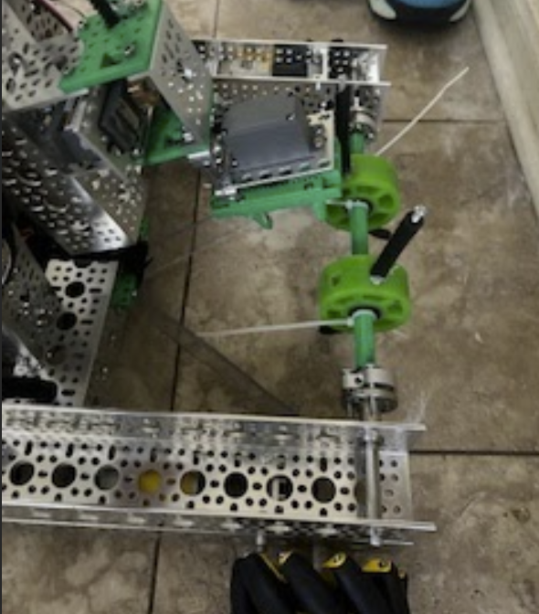 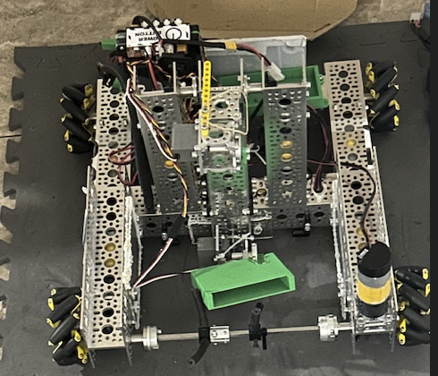 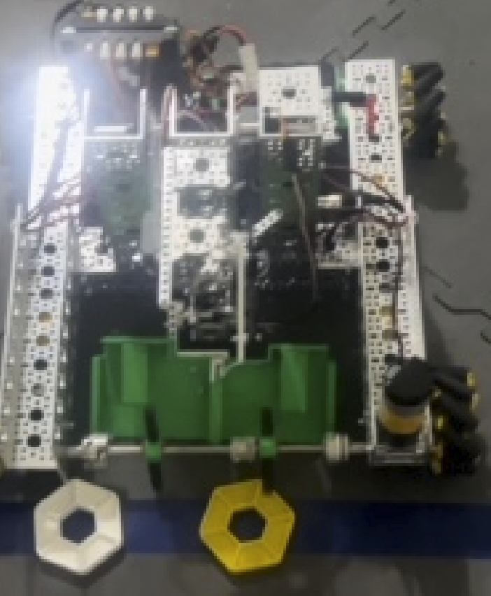

1. **Volunteering, Community Service-FLL Event Mentoring**

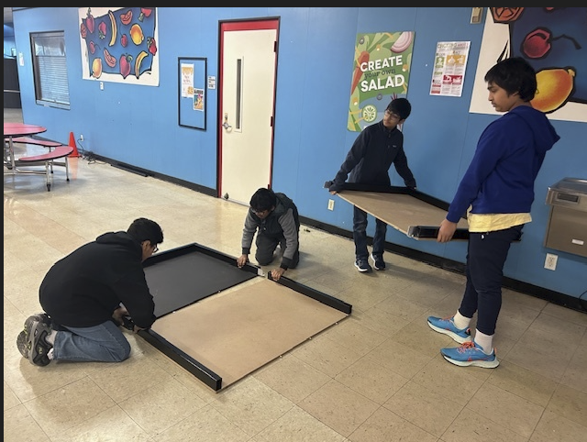 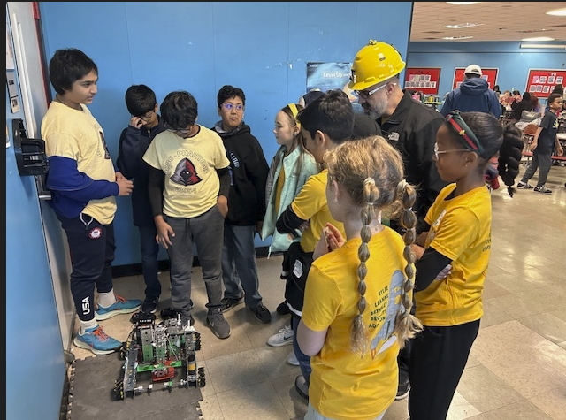

**Outreach Fundraising**

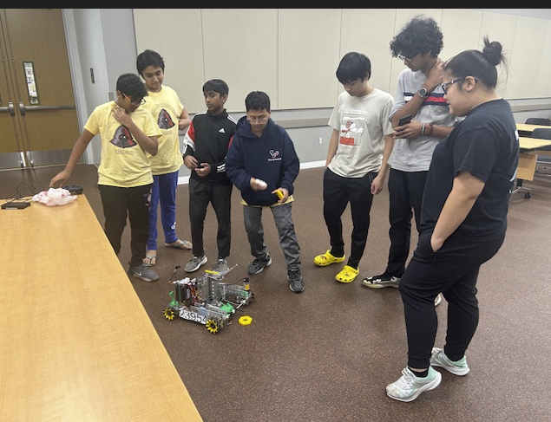 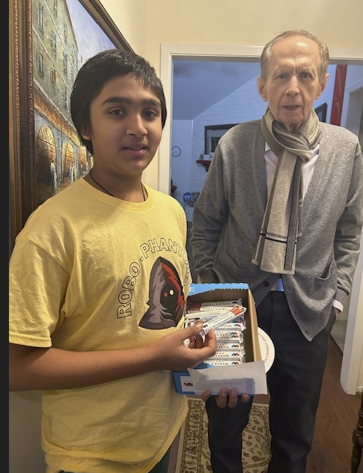

1. **CAD Sample**

